**The Socioeconomics of Pedestrian Accidents:**

Does your socioeconomic status impact your likelihood of being involved in a pedestrian – motor vehicle accident.

Jacob Geeves

Matthew Tenney

CSDA-1050F18S1

August 27, 2019

**Introduction**

Every year pedestrians continue to be involved in motor vehicle collisions. Thought the city continues to employ multiple methods to improve road safety for these users, the idea that inequality and safety are tied to the socioeconomic status of an area is prevalent. The purpose of this project is to study the relationship between a person’s socioeconomic status and their likelihood of being involved in a pedestrian – motor vehicle accident. This information can then be leveraged in determining locations where road safety improvements will have the biggest impact in lowering the socioeconomic inequality in the city of Toronto.

There are a number of papers and studies that have drawn the link between socioeconomic status and the likelihood of being involved in a vehicular accident. These studies have often taken a broad approach looking at how socioeconomics impacts all vehicular accidents. In this study we will be trying to determine if the socioeconomic status of a given area has an impact on the likelihood of pedestrians being hit by a vehicle.

# **Data Sources**

The data presented in this paper is based on 3 key data sources:

1. KSI Pedestrian Dataset
   * a subset of the Killed and Seriously Injured (KSI) dataset collected by the Toronto Police Service from 2008-2018
2. KSI TTC/Municipal Vehicle Dataset
   * a subset of the Killed and Seriously Injured (KSI) dataset collected by the Toronto Police Service from 2008-2018
3. Neighbourhood Boundaries - City of Toronto
   * a spatial dataset that defines the boundaries of all the neighbourhoods in the city
4. Simply Analytics - Census Data
   * A pair of spatial datasets that define the boundaries of all census tracts and census dissemination areas in the city of Toronto as well as average income by dissemination area.

# **Definitions**

Before we can proceed with the review, we also have to define some key terms.

Table 1

Key Terms

| Term | Definition |
| --- | --- |
| KSI | Database records maintained by the Toronto Police Service pertaining to vehicular accidents that resulted in someone being killed or seriously injured (Toronto Police Service) |
| LIM | Low Income Measure - individuals live in low income if their household after-tax income falls below half of the median after-tax income, adjusting for household size. (Statistics Canada) |
| Median Income | This is the level of income at which half the population had higher income and half had lower. (Statistics Canada) |

# **Data Review**

The KSI dataset maintained by the Toronto Police Service contains the majority of data we are reviewing. It includes not only details on the location of each accident but a description of what the pedestrian and driver were doing (PEDTYPE), what type of measures were in place to control the flow of traffic (TRAFFCTL), etc.

While the KSI dataset contains a lot of data about any given accident its information is limited to the accident itself does not contain data about the area where an accident occurred or personal information about the people involved in the accident (such as what area of the city they are from). Combining an average income variable available from the census to our KSI allows us to start looking at each accident to determine not only cause but to see if there is any correlation from one area to another.

As we take a closer look at our data, we can clearly see that the highest volume of pedestrian accidents is occurring in neighbourhoods where the average household income is between $60K and $90k. Assuming the average household income is attributable to the income of two earners that would equate to an average salary per person of $30k to $45k per year after tax.

As per Statistics Canada the Median After-Tax Household Income in 2017 for the city of Toronto was $69,100. (Persons not in an economic family coming in at just below 32,400, and economic families coming in at 88,600k) (Statistics Canada Table: 11-10-0190-01)This is in line with the average household incomes from our data set without only a few instances where incomes fall to a level that would be considered low income (approx. 45K and below depending on family size).

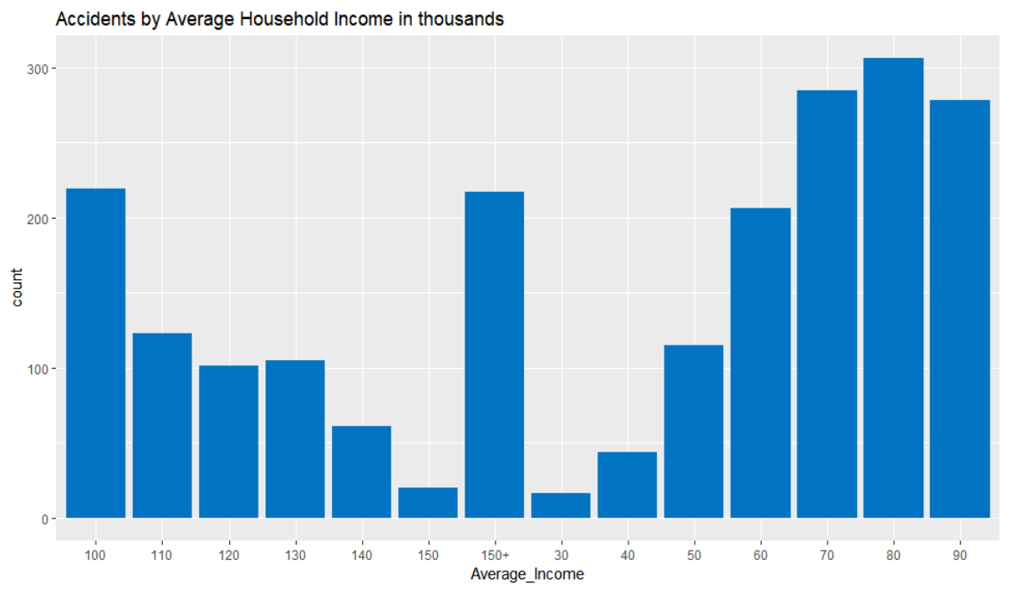

Figure . Frequency of Pedestrian Accidents at each Income Level

As the average household income increases above $100K per year, accident frequency drops off dramatically. (Figure 1) This trend also appears to be stable year over year. (Figure 2)

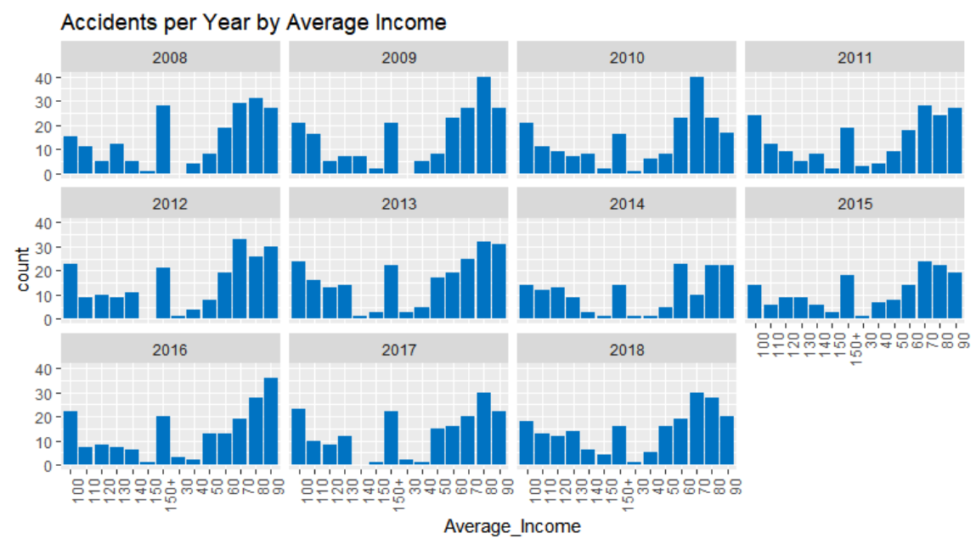

Figure . Yearly Frequency of Pedestrian Accidents at each Income Level

Looking at the various data variables in the KSI data, the data is telling a very clear story. Accidents are primarily occurring on major arterial roads in clear daylight and dry conditions. But two of the variables begin to introduce uncertainty into the narrative. (Figure 3) It’s a bit of a tossup whether an accident will occur at an intersection or not at an intersection and a similar toss-up if there was a traffic light or no traffic control. But given that traffic lights are usually only placed at intersections it would seem that these two pieces of data are relating the same information. We will choose to focus on the accident location, whether the accident occurs at an intersection or not at an intersection.

|  |  |
| --- | --- |
|  |  |
|  |  |
|  |  |

Figure . Accidents by Road Class, Location, Traffic Control Measure, Visibility, Lighting, and Road Condition

If we graph these two variables against each other we can clearly see that our intuition is correct. When an accident occurs at an intersection, the intersection was typically controlled by traffic signal. When an accident does not occur at an intersection there is typically no traffic control measures in place.

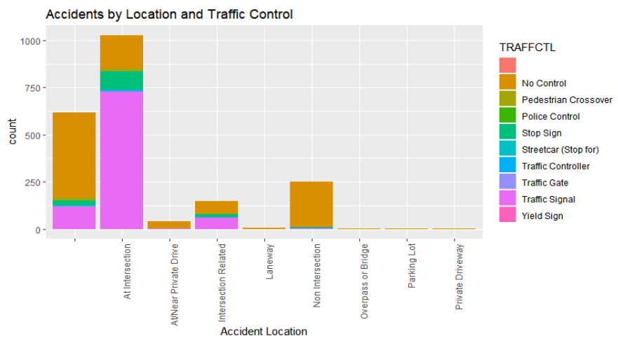

Figure . Accidents by Accident Location and Traffic Control Measure

We would naturally assume that traffic signals, baring other driver related factors, would make intersections safer for pedestrians provided of course that the pedestrian is following the traffic signals. But that does not appear to be the case. The KSI data does provide a series of 5 variables that influence the driver’s capacity to safely drive their vehicle. These are namely speeding, aggressive driving, running red lights, alcohol, or a disability. We will be referring to these collectively as driver influences.

If we graph these driver influences against the accident location, we see that at intersections over half the accidents at an intersection are as a result of aggressive driving while a very small percentage are the result of speeding or alcohol. Accidents not occurring at an intersection more often than not have no specified driver influence. (Figure 5)

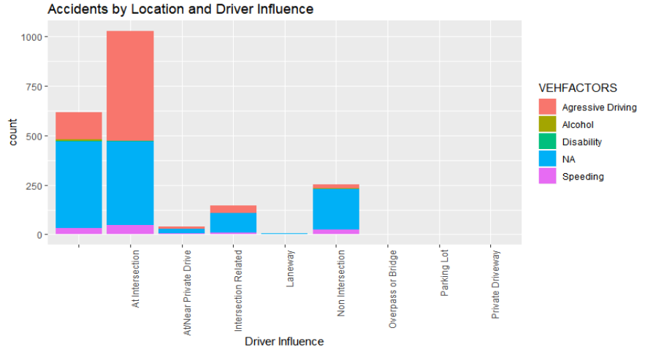

Figure . Accidents by Accident Location and Driver influence

If we focus for a moment on accidents occurring at intersections, we can add in the pedestrian action variable from our KSI data to get a better idea of what action the pedestrian is taking when they are hit. If we take the “At intersection” column from the graph above and add the pedestrian action variable we can see that when aggressive driving is a factor, pedestrian accidents at an intersection appear to be the result of driver error given that the vast majority of cases involve pedestrians crossing while they have the right of way. (Figure 6)

By contrast, pedestrian accidents at an intersection that don't involve aggressive driving seem to involve the pedestrian crossing without the right of way or at an intersection with no traffic control. (Figure 6)

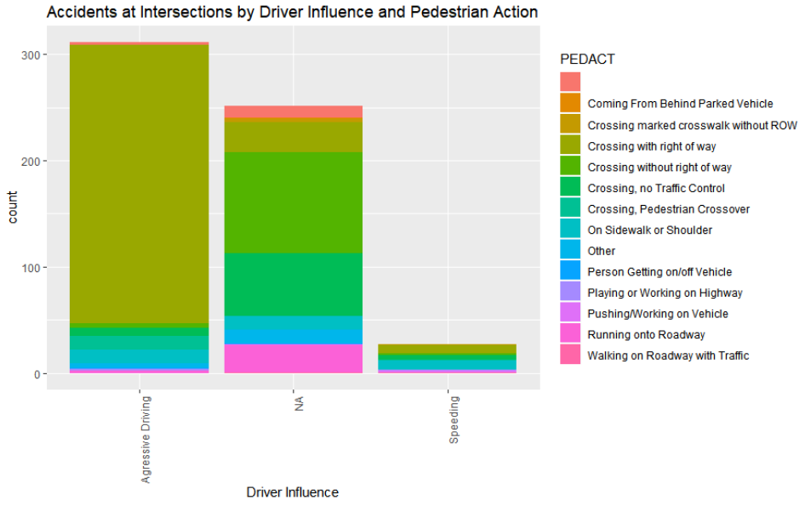

Figure . Accidents at intersections by Driver influence and Pedestrian Action

Swapping out the Pedestrian Action variable with the Vehicle Action variable we can see that when aggressive driving is involved, pedestrian accidents are occurring at intersections when the driver is turning left or right and much less frequently when they are driving straight through the intersection.(Figure 7)

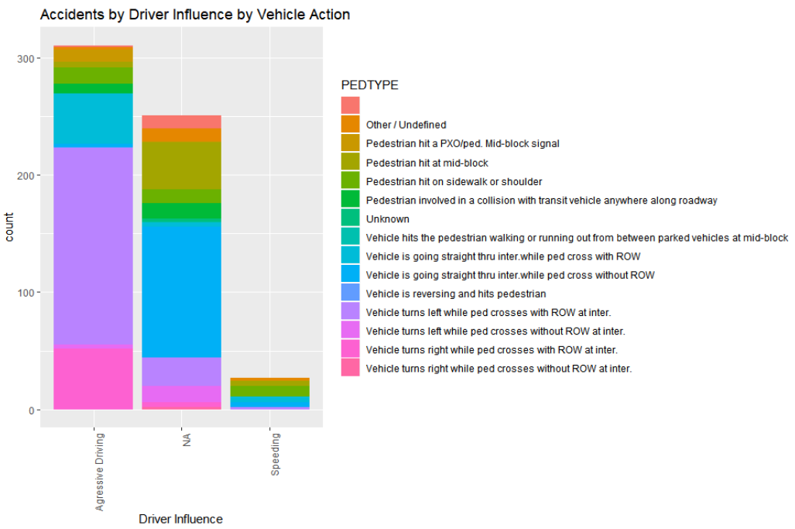

Figure . Accidents at Intersections by Driver Influence and Vehicle Action

If we focus instead on accidents occurring at undefined locations, we can see that a large majority of accidents do not involve any specified driver influence but that there are 3 types of action that seem to dominate; namely running out into the roadway, getting on/off a school bus, and crossing where no traffic control is in place. (Figure 8) This correlates to a pedestrian most frequently being struck by a vehicle midblock or while attempting to cross the roadway without the right of way. (Figure 9)

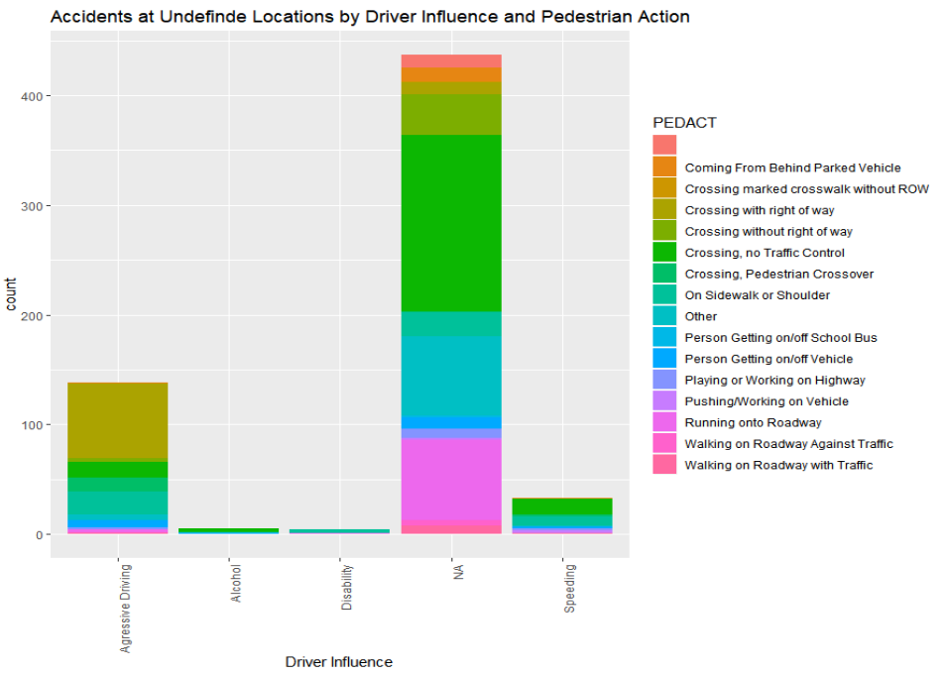

Figure . Accidents at Undefined locations by Driver influence and Pedestrian Action

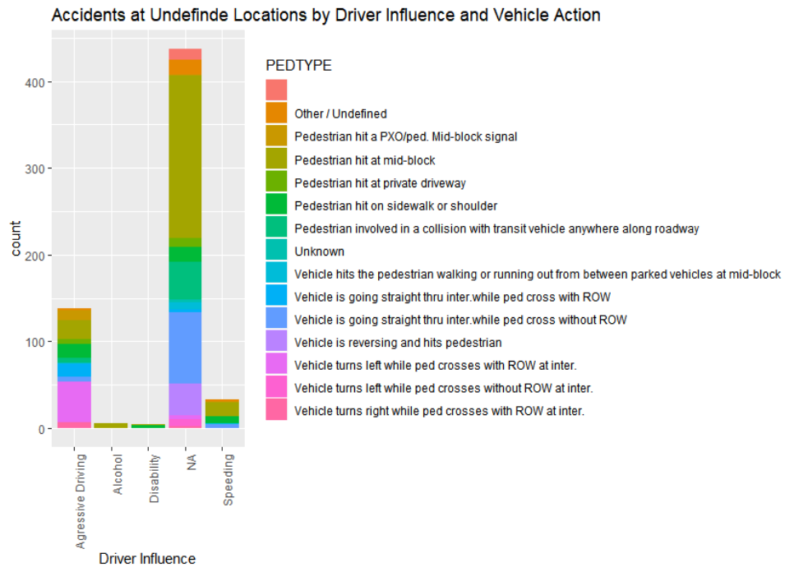

Figure . Accidents at Undefined Locations by Driver Influence and Vehicle Action

If we bring in average income as a variable the we can clearly see that the frequency distribution of accidents by income level that we saw in Figure 1 and Figure 2. We can also see that this distribution is unaffected by any factor we have reviewed so far.

# **Conclusion**

Our intention with this review was to determine if the socioeconomic status of a given area affects the likelihood of a pedestrian being hit in that area. We have seen that total number of accidents per year does not fluctuate widely. We have also seen that accidents occur in the same district at approximately the same proportion every year. And we have seen that no single factor or combination of factors seems to disrupt the distribution of accidents.

Ultimately, we have clearly demonstrated that if you are walking in a mid to low income neighbourhood you are at a higher risk of being hit by a vehicle than if you are walking in a higher income neighbourhood. However, there insufficient evidence in the data available to definitely identify average household income as the reason for this increased in risk.

We can however say that in Etobicoke, North York, and Scarborough there is a very evident issue in these low to middle income neighbourhoods of aggressive driving resulting in pedestrian accidents. (Figure 10) Since we have also clearly linked these aggressive driving accidents to right and left hand turns, it may be wise for the city to investigate measures that could be put into place to prevent these issues such as dedicated periods for all lane pedestrian crossings, limiting left turns to designated turning windows, or staggering the pedestrian and vehicular traffic signals similar to jurisdictions such as Montreal to ensure that the pedestrian will be half way through the intersection before drivers receive the right to proceed.

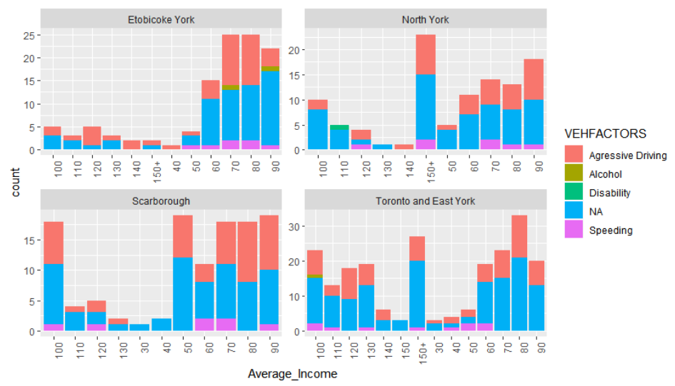

Figure . Accidents per District by Average Income and Driver Influence

# **Works Cited**

Statistics Canada. *Canadian Income Survey, 2017*. 26 02 2019. <https://www150.statcan.gc.ca/n1/daily-quotidien/190226/dq190226b-eng.htm>.

Statistics Canada Table: 11-10-0190-01. *Market income, government transfers, total income, income tax and after-tax income by economic family type*. 27 08 2019. <https://www150.statcan.gc.ca/t1/tbl1/en/tv.action?pid=1110019001&pickMembers%5B0%5D=1.17>.

Toronto Police Service. "KSI Pedestrian Dataset." n.d. *Public Safety Data Portal.* <http://data.torontopolice.on.ca/pages/pedestrians>.

# **Table of Figures**

Figure 1. Frequency of Pedestrian Accidents at each Income Level 3

Figure 2. Yearly Frequency of Pedestrian Accidents at each Income Level 4

Figure 3. Accidents by Road Class, Location, Traffic Control Measure, Visibility, Lighting, and Road Condition 5

Figure 4. Accidents by Accident Location and Traffic Control Measure 6

Figure 5. Accidents by Accident Location and Driver influence 7

Figure 6. Accidents at intersections by Driver influence and Pedestrian Action 8

Figure 7. Accidents at Intersections by Driver Influence and Vehicle Action 9

Figure 8. Accidents at Undefined locations by Driver influence and Pedestrian Action 10

Figure 9. Accidents at Undefined Locations by Driver Influence and Vehicle Action 10

Figure 10. Accidents per District by Average Income and Driver Influence 12